

Office Communications Online Standard
Service Description
Updated: November 2009
For the latest information, please see http://www.microsoft.com/online.

The information contained in this document represents the current view of Microsoft Corporation on the issues discussed as of the date of publication. Because Microsoft must respond to changing market conditions, it should not be interpreted to be a commitment on the part of Microsoft, and Microsoft cannot guarantee the accuracy of any information presented after the date of publication.
This document is for informational purposes only. MICROSOFT MAKES NO WARRANTIES, EXPRESS, IMPLIED OR STATUTORY, AS TO THE INFORMATION IN THIS DOCUMENT.
Complying with all applicable copyright laws is the responsibility of the user. Without limiting the rights under copyright, no part of this document may be reproduced, stored in or introduced into a retrieval system, or transmitted in any form or by any means (electronic, mechanical, photocopying, recording, or otherwise), or for any purpose, without the express written permission of Microsoft Corporation.
Microsoft may have patents, patent applications, trademarks, copyrights, or other intellectual property rights covering subject matter in this document. Except as expressly provided in any written license agreement from Microsoft, the furnishing of this document does not give you any license to these patents, trademarks, copyrights, or other intellectual property.
©2009 Microsoft Corporation. All rights reserved.
Microsoft, SharePoint, Outlook, Excel, Windows, Windows Vista, Windows Mobile and Active Directory are either registered trademarks or trademarks of Microsoft Corporation in the United States and/or other countries.
All other trademarks are property of their respective owners.

Contents
Introduction 4
Why Office Communications Online? 5
Features of Microsoft Online Services 6
System Requirements 7
Sign In Application 7
Language Support 7
Features of Office Communications Online 9
Microsoft Office Communicator 2007 R2 Support 9
Trial and Purchase Information 9
Limited Time Offer 9
Instant Messaging 10
Presence 10
Presence Integration with Microsoft Office 10
Integration with Microsoft Online Services and On-Premise Servers 10
Remote Access 11
Distribution Lists 11
Securing IM 12
Service Continuity Management 12
Service Administration 14
More Information 15
Appendix A: Office Communications Online and Office Communications Server 2007 R2 Feature Comparison 16

Introduction
Microsoft® Office Communications Online is a hosted, enterprise-class communications solution based on Microsoft Office Communications Server 2007 R2. Office Communications Online provides your organization with real-time communications capabilities including secure instant messaging and delivery of "presence" information. Presence enables users to see at a glance if someone is available online to receive an instant message.
Your organization can purchase Office Communications Online as a standalone service from Microsoft Online Services or as part of the Business Productivity Online Suite—which includes Microsoft Exchange Online, Microsoft SharePoint® Online, and the Microsoft Office Live Meeting service.
This service description is intended to help IT professionals and describes the features that are included with the Standard offering of Office Communications Online.

Why Office Communications Online?
As an enterprise-class instant messaging and presence solution, Microsoft Office Communications Online helps individuals be more productive without increasing their company’s IT burden. Here are some of the key benefits of the service.
Business-class presence and instant messaging
Phone or e-mail "tag" is an all too common communications problem in today’s business world. Often the problem stems from workers lacking visibility into other people's availability or "presence." Presence information is especially important when there is a need for a critical business discussion or a time-sensitive decision has to be made. Office Communications Online helps organizations increase individual productivity by combining presence with instant messaging in a secure environment.
Real-time collaboration capabilities within Office programs
Office Communications Online adds real-time collaboration capabilities and presence to the Microsoft Office programs workers use on a regular basis, such as Microsoft Office Outlook®, Microsoft Office Excel®, and Microsoft Office Word. Integrating presence in these applications helps integrate collaboration into the everyday workflow.
Collaboration capabilities within SharePoint sites
Office Communications Online serves as the presence engine for Microsoft SharePoint Online sites and portals, providing presence and IM access from within SharePoint sites. SharePoint Online is a separate service available from Microsoft Online Services.
Reduced travel and IT costs
Using Office Communications Online allows person-to-person communication across an organization without expensive business travel or costly long-distance or international calls. The service gives organizations the opportunity to focus IT resources on developing value instead of running IT infrastructure. Microsoft manages the risks and complexity of operational systems.
Reliability
Microsoft has extensive expertise with Office Communications Server, supporting more than 100,000 global users on the Microsoft internal network. Since 2003 when the product was introduced, Microsoft has implemented Office Communications Server client and server services in an array of environments and developed best-in-class deployment and operational practices along the way.
Timely platform upgrades
The Office Communications Online service is regularly upgraded to take advantage of new features that become available with service pack releases or new versions of Office Communications Server. Any upgrade to the service is available to customers at no additional charge. This means that companies are not burdened with the planning and execution of upgrades and their users can start working with the latest features and improvements without delay.

Features of Microsoft Online Services
Office Communications Online is one of a suite of services available from Microsoft Online Services. Microsoft Online Services are Internet-based services hosted by Microsoft that make it easier for a business to rapidly—and cost-effectively—access the latest communication and collaboration technologies. They help deliver business-class reliability and reduce the burden of performing routine IT management tasks such as installation, provisioning, ongoing maintenance, patches, updates, and upgrades.
Office Communications Online subscribers benefit from a set of features that are common to all Microsoft Online Services offerings:
- Secure access: Microsoft Online Services are accessed via 128-bit Secure Sockets Layer (SSL) encryption. Anyone who intercepts a communication sees only encrypted text.
- Business continuity: Redundant network architecture is hosted at geographically dispersed Microsoft data centers to handle unscheduled service outages. Data centers act as backups for each other: If one fails, the affected customers are transferred to another data center with limited interruption of service.
- Intrusion monitoring: Microsoft continuously monitors the Microsoft Online Services systems for any unusual or suspicious activity. If Microsoft detects such activity, it investigates and responds as appropriate. In the unlikely event that a significant incident occurs, the customer is notified.
- Security audits: Ongoing assessment of the Microsoft Online Services infrastructure ensures installation of the latest compliance policies and antivirus signatures, along with high-level configuration settings and required security updates.
- High availability: Microsoft Online Services has a 99.9 percent scheduled uptime. If a customer’s service is affected, Microsoft Online Services offers financial remedies subject to the terms and conditions of the service level agreement (SLA).
- Support: Web form and phone support is available 24 hours a day, 7 days a week, for the service administrator.
- Administration Center: This easy-to-use Web site is made available to your service administrators for managing all Microsoft Online Services. This is also where service administrators can download software, such as the Microsoft Online Services Sign In application, Directory Synchronization tool, and Migration Tools.
- My Company Portal: Users log on to the My Company Portal Web site to launch Microsoft Online Services. There they can access services such as e-mail, create a SharePoint site, download the Sign In application—and more.
- Sign In application: This tool conveniently allows Microsoft Online Services end users to sign in once and access all services without being prompted repeatedly for their password.
- Virus filtering: Microsoft Online Services helps guard against online threats that could potentially affect Microsoft Exchange Online and Microsoft SharePoint Online users. Microsoft Forefront™ Online Security for Exchange automatically removes viruses and spam in incoming and outgoing e-mail. Microsoft Forefront Security for SharePoint scans for viruses in intracompany e-mail and in all documents that reside in SharePoint Online sites.
- Directory Synchronization tool: For subscribers with an on-premise Active Directory® service deployment, this tool helps keep the on-premises Active Directory and the Microsoft Online Services directory in sync.

System Requirements
The system software that is necessary to access Microsoft Online Services is shown in Table 1.
Table 1: Microsoft Online Services Supported Software
Software | Supported Version
Operating systems | Windows Vista® Business SP1  Windows Vista Enterprise SP1  Windows Vista Ultimate SP1 | Windows XP® Professional SP2  Windows XP Tablet SP2  Apple Macintosh OS X 10.5¹
System software | Microsoft .NET Framework 3.0 (for Windows XP)  Java client 1.4.2 (for Macintosh OS X) ²
Client application | Microsoft Online Services Sign In application
Browser software | Microsoft Internet Explorer® 6  Windows® Internet Explorer 7  Windows® Internet Explorer 8 | Mozilla Firefox 3³  Apple Safari 3 (for Macintosh OS X 10.5)¹
¹Office Communications Online is not supported
²Java required for Microsoft Office Live Meeting only.
³Some functionality may be limited.

Sign In Application
The Microsoft Online Services Sign In application is installed on all end users’ computers to provide a single sign-in point for Microsoft Online Services. A service administrator may deploy the Sign In application to each computer in the company, or instruct users to install it themselves from the Downloads tab on My Company Portal.
The Sign In application provides these features:
- Automatic configuration of applications: The Sign In application automatically configures desktop applications on the end user’s computer so that they work properly with Microsoft Online Services. This saves time and trouble for first-time users and reduces support time for service administrators. If necessary, users can also reconfigure their desktop applications manually within the Sign In application.
- Single access point for services: Instead of having to sign in to each available service, users can use the Sign In application once, and then launch service applications without any additional sign-in requests. The Sign In application lists all services that the company’s service administrator has made available to the user. The online services available to users depend on the licenses that your company purchases.
- Password management: Users can change their service password in the Sign In application, and if their password expires, the Sign In application alerts them and offers the means to update it.

Language Support
Languages supported by Office Communications Online and other Microsoft Online Services offerings and components are described in Table 2.
Table 2: Microsoft Online Services Language Support
Service | Supported Languages
SharePoint Online | English, French, German, Japanese, Spanish
Exchange Online | Languages for Microsoft Office Outlook and Microsoft Outlook Web Access clients are detailed at Exchange 2007 Language Support.
Office Communications Online | Arabic, Bulgarian, Chinese (Hong Kong), Chinese (Simplified), Chinese (Traditional), Croatian, Czech, Danish, Dutch, Estonian, French, Finnish, German, Greek, Hebrew, Hindi, Hungarian, Italian, Japanese, Korean, Latvian, Lithuanian, Norwegian, Polish, Portuguese (Brazil), Portuguese (Portugal),Romanian, Russian, Serbian, Slovak, Slovenian, Spanish, Swedish, Thai, Turkish, Ukrainian
Office Live Meeting | Chinese (Simplified), Chinese (Traditional), Danish, Dutch, English, Finnish, French, German, Italian, Japanese, Korean, Portuguese (Brazil), Spanish, Swedish
Microsoft Online Services Web portals and Sign In application | English, French, German, Japanese, Spanish
Exchange Hosted Filtering, Encryption, and Archive* | Chinese (Simplified), Chinese (Traditional), Dutch, English, French, German, Italian, Korean, Japanese, Portuguese (Brazil), Portuguese (Portugal), Spanish, Russian
* Exact release dates for languages to be determined.

Features of Office Communications Online
This section describes the features of the Microsoft® Office Communications Online service. Where applicable, service options are noted along with feature limits.
Table 3 provides a summary of the key features.
Table 3: Office Communications Online Key Features
Feature | Description
Service access | Requires Microsoft® Office Communicator 2007 R2  (separate purchase and installation required)
Contact List | Users can have up to 250 contacts
Distribution Lists | Each list counts as one contact  Lists with more than 100 members cannot be expanded
2007 Microsoft Office system integration | Office Access 2007  Office Excel® 2007  Office InfoPath® 2007  Office Outlook® 2007 | Office PowerPoint® 2007  Office SharePoint Designer 2007  Office Word 2007

Microsoft Office Communicator 2007 R2 Support
Office Communications Online requires the separate purchase and installation of Microsoft® Office Communicator 2007 R2. Office Communicator 2007 is the enterprise desktop client that enables users to send and receive instant messages, organize and manage a Contact List, and monitor presence information for contacts.
Office Communicator 2007 R2 requires that client computers run one of the following operating systems:
- Windows® Vista™ (32-bit)
- Microsoft® Windows® XP SP2
Limit
Microsoft Online does not support client deployment in a customer organization. Microsoft recommends that organizations work with their IT partner if they need assistance deploying Office Communicator to users.

Trial and Purchase Information
The following sites provide information on trying and purchasing Office Communicator 2007 R2.
- For a trial download of Office Communicator 2007 R2, please visit http://www.microsoft.com/downloads/details.aspx?FamilyID=535637af-d92f-41b1-bf0c-54a526a88247.
- Enterprise customers interested in purchasing Office Communicator 2007 R2 should visit http://www.microsoft.com/licensing/howtoacquire.mspx.
- Small business customers interested in purchasing Office Communicator 2007 R2 should visit http://www.microsoft.com/smallbusiness/buy/software/overview.aspx#VolumeLicensing.

Limited Time Offer
Receive one licensed copy of Office Communicator 2007 R2 at no cost with each subscription license to Office Communications Online. The software may only be used with Office Communications Online, and all rights to use the software will terminate upon expiration of the underlying subscription license or release of the next major new version of Office Communications Online, whichever comes first.

Instant Messaging
Instant messaging (IM) is a quick and convenient way for users to send text messages to other users in real time over the Internet or a corporate network. Office Communications Online automatically encrypts IM text for added security.
Instant messaging requires that Office Communicator 2007 R2 be installed on client systems.

Presence
A core capability of Office Communications Online is presence–the ability to detect another user’s availability on the network. Using Office Communicator 2007, users can display their presence availability status—for example, Available, Busy, Away, Do Not Disturb or Offline—to let others know their availability to be contacted. Presence information can also display other contact information such as a person's phone number.
To easily monitor the presence information of another user, users can add other users to their Contact List and can organize and group these contacts in different ways (by department, for example). Users may also search their company’s address book to find other users—which means it is not necessary to add someone to the Contact List in order to detect presence or send an instant message.
Displaying presence information requires that Office Communicator 2007 R2 be installed on client systems.
Limits
- Office Communications Online users may have no more than 250 contacts in their Contact List.
- Presence subscribers for an individual user may not exceed 250. A Presence subscriber is a user who can see the published availability of another user and receives updates as this availability changes.

Presence Integration with Microsoft Office
Office Communications Online integrates presence with Microsoft® Office 2007 SP1 or later programs. This feature enables users to instantly find and communicate with people while working with familiar applications such as Microsoft Office Outlook, Microsoft Office Excel, Microsoft Office Word, and Microsoft Office SharePoint.
Presence information is offered through the Microsoft Office program interface with presence icons that appear in lists and XML-based Web Parts. A colored presence button that represents a person’s presence status lets users instantly see who is online and available to discuss documents or upcoming meetings, regardless of time zone or location.
For organizations using Microsoft Exchange Server 2007 messaging services, presence information can also display a person’s schedule based on their Outlook calendar. This makes it easy to determine when someone will be available to communicate.

Integration with Microsoft Online Services and On-Premise Servers
Office Communications Online presence functionality integrates seamlessly with the Microsoft Online Services offerings Exchange Online and SharePoint Online. This includes presence status in Outlook, calendar information for presence and out-of-office in Office Communicator and click-to-communicate via Communicator from SharePoint Online.

Office Communications Online integration capabilities with on-premise server deployments are as follows:
- Microsoft Exchange Server: Office Communications Online integration with an on-premise deployment of Microsoft Exchange Server 2007 is supported. The service provides automatic presence updates based on calendar information and Out of Office details that appear in Office Communicator. Note that Office Communicator will use the external Web URLs defined for Exchange servers. For more information about Exchange server URLs, please visit http://technet.microsoft.com/en-us/library/aa996902.aspx.
- Office Communications Server: Office Communications Online integration with an on-premise deployment of Office Communications Server 2007 is not supported.
Organizations using Exchange Online will have full Presence integration with Office Communications Server 2007 R2, including presence status in Outlook, calendar information for presence and out-of-office in Office Communicator. Note that the version of Office Communicator 2007 R2 must include the October 2009 update or later. To obtain this update please see http://support.microsoft.com/kb/972884.
Without this update the following limitations apply: Office Communicator, when connected to an on-premises server running Office Communications Server, will not receive updates based on calendar status or Out-of-Office information from Exchange Online. For example, Office Communicator Free-Busy information will not change to indicate that a user is in a scheduled meeting.

Audio/Video Communication
The Office Communications Online service delivers person-to-person (1:1) audio and video conversations for users equipped with a headset device and Web camera. Conversation quality may vary depending on customer network performance. Your company must provide and support headsets and Web cameras using an approved product list from Microsoft.
Limit
Person-to-person audio and video communication can occur only between two PCs on the same corporate network where no firewall or other devices exist between the computers.

Remote Access
The Office Communications Online service gives users the ability to connect directly to the service over the Internet, without users connecting to their corporate network through a Remote Access Service (RAS) or virtual private network (VPN).

Distribution Lists
Using Office Communicator 2007 R2, service users can add e-mail distribution lists to their Contact Lists. Instant messages may be sent to individual members of a distribution list or the entire distribution list.
Distribution lists can be expanded to see the individual members of such lists.
Limits
- Distribution list expansion is allowed only for distribution lists with 100 or fewer individual members (regardless of the members’ presence or sign-in status).
- Distribution lists with more than 100 members are allowed but these distribution lists may not be expanded to display individual members of the list.
- A distribution list counts as one contact against the 250 contact limit per user. The distribution list counts as one contact regardless of the number of individual members within the distribution list.

Securing IM
Microsoft has extensive experience in designing and operating a highly available instant messaging solution. One key component is the Intelligent Instant Message Filter (IIMF) program, which helps protect both the customer network and the Microsoft managed network against the spread of the most common viruses and spam.
The IIMF program helps increase security by providing enhanced URL filtering and enhanced file filter control. Microsoft has a default IIMF design that is built upon years of operating scalable, global IM systems. However, Microsoft will work with companies to evaluate the best security options for their specific environment. In addition, companies should use client antivirus protection to increase security.
By using the IIMF program, Microsoft can enable URL filtering for the following:
- Allow hyperlinks to be sent in any conversation
- Allow local intranet URLs
- Block all intranet hyperlinks that contain defined file extensions
- Block instant messages that contain hyperlinks
- Allow instant messages that contain hyperlinks but convert the links to plain text
- Allow instant messages that contain active hyperlinks

Service Continuity Management
Office Communications Online is hosted in Microsoft managed enterprise-level data centers that are designed to deliver highly available, highly resilient online services. Because of this, the Office Communications Online services are available at 99.9 percent uptime.
However, service availability can be affected by hardware failures, natural disasters, and human error. To address this, Office Communications Online offers service continuity management, a process for managing risks to ensure that a company’s IT infrastructure is capable of providing continuing services if normal availability solutions fail. Service continuity management for Office Communications Online includes provisions to quickly recover from such unexpected events.
Two metrics commonly used in service continuity management to evaluate disaster recovery solutions are:
- Recovery time objective (RTO) measures the time between a system disaster and the time when the system is again operational.
- Recovery point objective (RPO) measures the time between the latest backup and the system disaster, representing the nearest historical point in time to which a system can recover.
Office Communications Online has set the following RPO and RTO in the event of a disaster:
- 24-hour RPO: In the event of a failover to a secondary data center, Office Communications Online will restore a copy of the customer’s Contacts and access control list (ACL) data that is equal to or less than 24 hours old at the time of failure.
- 72-hour RTO: Customers will be able to resume service within 72 hours of a service disruption if a disaster incapacitates the primary data center.
Note: Microsoft expects to achieve an 8-hour RPO and 24-hour RTO for Office Communications Online by the second half of 2009.
Microsoft provides service continuity testing for customers once every 12 months.
The following services are available within the RTO:
- Instant messaging and presence
- Remote access via the Internet
- User account provisioning

Service Administration
The Microsoft Online Services Administration Center is a Web portal that a customer’s service administrator uses to manage the Microsoft Online Services the company has subscribed to—including the Office Communications Online service.
Administration Center navigation is organized according to five tabs. The service administrator accesses Office Communications Online settings by clicking the Service Settings tab, shown in Figure 1.
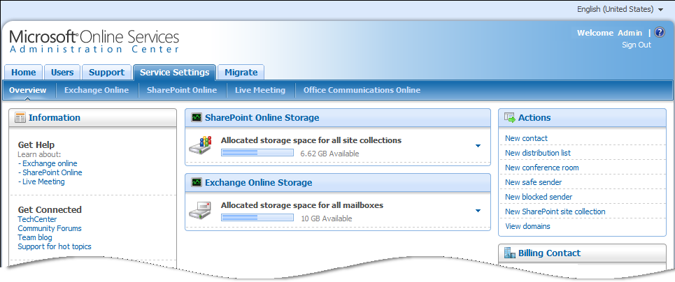
Figure 1: The Service Settings tab of the Administration Center
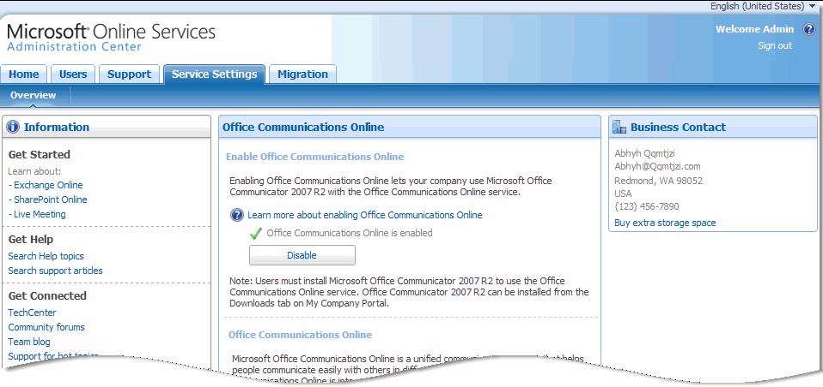
On the Office Communications Online subtab, shown in Figure 2, service administrators can enable and disable Office Communications Online services for their organization.

Figure 2: Office Communications Online subtab.

More Information
The following resources can help you learn more about Office Communications Online and Microsoft Online Services:
- Microsoft Online Services Portal: Learn more about online services from Microsoft, sign up for free trials, and purchase services.
- Microsoft TechNet: Business Productivity Online
Exchange Online is part of the Business Productivity Online Standard Suite, a group of Microsoft Online Services that include Exchange Online, SharePoint Online, Live Meeting, and Office Communications Online. At this TechNet site you will find detailed information about Exchange Online features and step-by-step instructions about how to set up and configure service features.
- Microsoft Online Services Blog
Read the latest posts from service team members and stay up to date on new developments.
- Security Features in Microsoft Online
In this white paper, learn how Microsoft concern for security, as defined in the Trustworthy Computing Initiative, has driven key features in the design, deployment, and operation of the Microsoft Online Services environment.
- Solutions Accelerators for Microsoft Online Services
Solution Accelerators automate discovery and assess requirements for migration to Microsoft Online Services and provide you with the prescriptive guidance and operations framework to speed up the onboarding and migration process.

Appendix A: Office Communications Online and Office Communications Server 2007 R2 Feature Comparison
Table A below describes the major capabilities and features of Office Communications Server 2007 R2 and identifies the features offered in the Office Communications Online standard service.
Table A: Office Communications Online Feature Capabilities
Capabilities | Feature | Available in OCO Standard service
Instant messaging and presence | Encrypted Text-based chat; presence + presence integration | Yes
Instant messaging and presence | Remote access (via the Internet) | Yes
Instant messaging and presence | File transfer | Yes*
Instant messaging and presence | 1:1 audio and video | Yes*
Instant messaging and presence | Distribution lists; distribution list expansion | Yes
Instant messaging and presence | Presence integration with Microsoft Outlook, Exchange & SharePoint | Yes
Instant messaging and presence | Support for Multiple clients (desktop, Web, mobile) | No
Instant messaging and presence | Intelligent instant message filter | Yes
Instant messaging and presence | Per-user account provisioning | Yes
Instant messaging and presence | Business partner federation (other than Microsoft) | No
Instant messaging and presence | Public IM connectivity (PIC) | No
Instant messaging and presence | IM archiving | No
Instant messaging and presence | Integration with third-party platforms or applications | No
OCS Web conferencing ** | 1:1 and multiparty desktop sharing | No
OCS Web conferencing ** | Multiparty audio and video | No
OCS Web conferencing ** | Support for Office Live Meeting client | No
OCS Web conferencing ** | Support for Office Outlook plug-in (scheduled meetings) | No
OCS Web conferencing ** | Support for anonymous users (PSTN/PBX integrated audio) | No
Enterprise voice (PBX/PSTN integration) | Incoming/outgoing PBX/PSTN calls and conferences using Office Communicator (click to call) | No
Enterprise voice (PBX/PSTN integration) | Integration with Exchange Server unified messaging (voicemail) | No
Enterprise voice (PBX/PSTN integration) | Enhanced incoming call control  (includes simultaneous ring plus call forwarding) | No
Enterprise voice (PBX/PSTN integration) | Third-party telephony integration | No
Enterprise voice (PBX/PSTN integration) | Integration with third-party platforms or applications | No
* Limited to two PC’s on the same corporate network (no firewalls or other devices can exist between the parties)
** OCS Web Conferencing is not currently offered in Office Communications Online. A capable alternative is the Microsoft Office Live Meeting service. Office Live Meeting provides rich multiparty collaboration capabilities and is available as part of the Microsoft Online Services and Business Productivity Online Suite (BPOS).

